In this document we are going to test and then talk about what you tested and the result of it. Once complete we will add this to the github and talk about it in our presentation too.

Test case 1: Check that someone can’t enter in a bad email.

Test Data: [test@gmail.com](mailto:test@gmail.com)

Expected Result: No error is thrown.

Result: No error was thrown.



Test Data: test@gmail

Expected Result: Error should be thrown.

Result: Error was thrown.

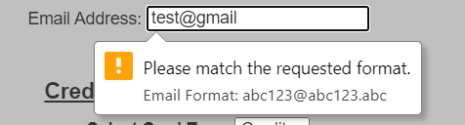

Test case 2: Check that someone can’t enter in bad card information.

Test Data: 1234567

Expected Result: Error should be thrown

Result: Error was thrown

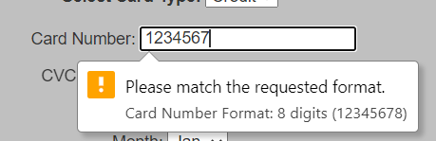

Test Data: 9

Expected Result: Error should be thrown

Result: Error was thrown

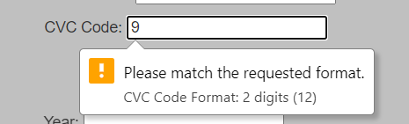

Test Data: 20

Expected Result: Error should be thrown

Result: Error was thrown

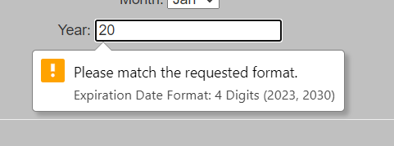

Test Data: 12345678

Expected Result: No error should be thrown

Result: No error was thrown



Test Data: 99

Expected Result: No error should be thrown

Resutl: No error was thrown



Test Data: 2022

Expected Result: No error should be thrown

Resutl: No error was thrown



Test case 3: All of the buttons navigate to the right page.

* Went from page to page to make sure that the buttons worked. All of the buttons went to the expected page when clicked.

Test case 4: The right pizza amount goes to cart when added.

Test Data: Select a small pizza size

Expected Result: Total should show $12.5

Result: Total says 12.5

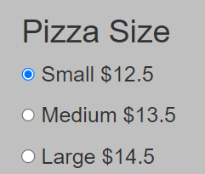

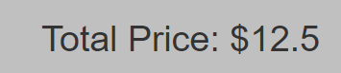

Test Data: Select a large pizza size

Expected Result: Total should show $14.5

Result: Total says 14.5

